
LCD + UART + DHT11 with FreeRTOS
Advanced Embedded Systems

Authors: Dr. Gilberto Ochoa Ruiz
Msc. Jorge German Perez Blanco
Contents
Introduction 3
Learning Objectives 3
What the Example Does 3
FreeRTOS Usage 5
Execution Flow 5
UART Interface 5
Suggested Tests 5
Annexes 6
Usage examples 6
Issuing a check command 6
Issuing an auto_on command 6
Issuing an invalid command 6
Application code 6
dht11.h 6
dht11.c 7
Main app code 10

Introduction
This example demonstrates how to integrate FreeRTOS with hardware peripherals on the NXP FRDM-KL25Z development board.
The application combines three essential concepts:
- Real-time operating system features (tasks, queues, mutexes, periodic scheduling).
- Peripheral control: driving a character LCD in 8-bit mode, reading a DHT11 temperature/humidity sensor, and handling UART communication.
- System design patterns: using interrupts to trigger events, synchronizing tasks with semaphores/queues, and protecting shared resources with a mutex.
Through this project, you will learn how to structure embedded applications using multiple concurrent tasks, how to exchange data safely between interrupts and tasks, and how to periodically sample a sensor while updating a user interface. The example serves as a foundation for building more complex real-time systems that combine sensing, processing, and human–machine interaction.

Learning Objectives
- Use FreeRTOS tasks with different priorities and periods.
- Transfer data from ISR to task via a queue (xQueueSendFromISR).
- Protect a shared resource (LCD) with a mutex.
- Implement a periodic task with vTaskDelayUntil() for DHT11 sampling.
- Control an LCD HD44780 in 8-bit mode, handling cursor positioning (0x80, 0xC0).

What the Example Does
- Displays a header (line 1) and data (line 2) on a 16×2 LCD.
- Accepts commands over UART:
  - check → shows a snapshot of the latest DHT11 reading.
  - auto_on → automatically updates line 2 with periodic DHT11 readings.
  - auto_off → disables automatic updates.
- A periodic task reads the DHT11 every 2000 ms and updates a buffer.
- The LCD renderer task writes header and body alternately every 500 ms.
How to send commands
To send commands to the device, we will use the Terminal included in the MCUExpresso IDE.
To establish the serial communication with the board through the Terminal, click on the button highlighted in the figure, located in the bottom panel under the Terminal tab.
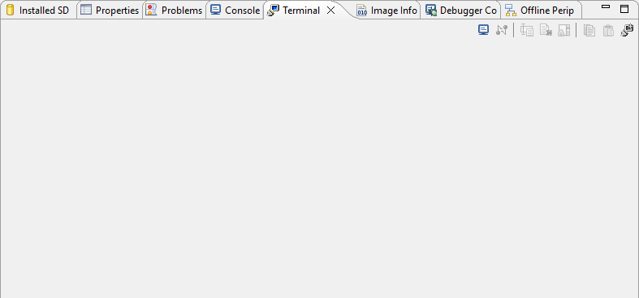
As a result, the terminal configuration window will appear, as shown in the following figure. Leave de defaukt configuration as it matches the UART configuration done by code, just press the Ok button and the serial communication with the board will start.
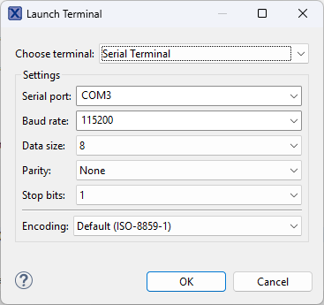
Now we need to enable the command input field that its disabled by default each time we open serial communication, otherwise we can’t send the commands. To toggle the command input field, press the button highlighted on the following figure, located in the bottom panel under the Terminal tab.
Now you are able to input commands to the board as shown on the next figure. Just type the command on the input field and press the Enter key of your keyboard.
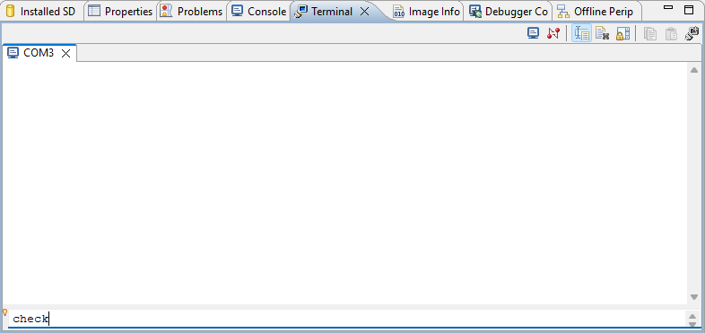

FreeRTOS Usage
- Tasks
  - vTaskLCDRenderer (prio 1, stack 256): updates LCD every 500 ms.
  - vTaskUART (prio 2, stack 256): processes UART commands.
  - vDHTReaderTask (prio 3, stack 256): reads DHT11 every 2000 ms.
- Queue
  - xQueueUART (4 items × 32 bytes): receives complete lines from UART ISR.
- Mutex
  - xMutexLCD: protects LCD_HEADER_BUFFER / LCD_BUFFER and LCD writes.
- ISR
  - UART0_IRQHandler: assembles command string and enqueues it.

Execution Flow
- main() initializes hardware, UART0, TPM0, LCD, DHT11, creates queue/mutex and tasks, then starts scheduler.
- UART0 ISR collects characters until CR/LF and enqueues the command.
- vTaskUART validates commands (check/auto_on/auto_off) and updates flags/buffers.
- vDHTReaderTask reads sensor every 2s; if auto_update is set, copies to LCD buffer.
- vTaskLCDRenderer alternates writing header and body to the LCD every 500 ms.

UART Interface
- Baudrate: 115200, Format: 8N1, no flow control.
- Commands: check, auto_on, auto_off.
- Invalid commands display “Invalid Command”.

Suggested Tests
- Functional: send auto_on → line 2 updates every ~2 s.
- Snapshot: check with auto_off active → line 2 stays fixed.
- Robustness: send invalid command or ≥16 chars → “Invalid Command”.
- Load: reduce LCD renderer period to 200 ms and observe jitter.

Suggested Changes
- Implement LCD_SetCursor(row, col) helper.
- Pad all LCD lines to exactly 16 chars.
- Switch LCD to 4-bit mode to free pins.
- Add UART echo or help command.

Annexes

Usage examples

Issuing a check command
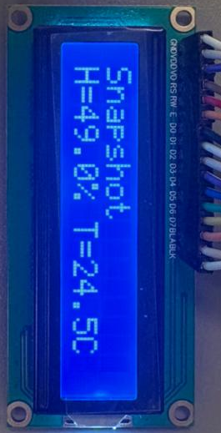

Issuing an auto_on command
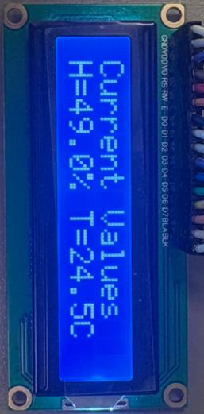

Issuing an invalid command
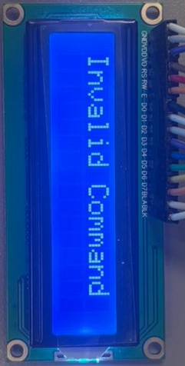

Application code

dht11.h
#ifndef DHT11_H
#define DHT11_H

#include <stdint.h>
#include <stdbool.h>

typedef struct {
uint8_t humidity_int;
uint8_t humidity_dec;
uint8_t temp_int;
uint8_t temp_dec;
} dht11_data_t;

/* Inicializa TPM0 (~1 MHz) y el pin GPIO (entrada con pull-up). */
void DHT11_Init(void);

/* Lee el sensor (bloqueante). Retorna true si el checksum es válido. */
bool DHT11_Read(dht11_data_t *out);

#endif

dht11.c
#include "dht11.h"
#include "MKL25Z4.h"

/* ===================== Configurable: pin del DHT11 ===================== */
#define DHT_PORT PORTC
#define DHT_GPIO GPIOC
#define DHT_PIN 7u /* PTC7 por defecto (NO usa Puerto D) */

/* ===================== Utilidades de temporización (TPM1) ============== */
static inline void tpm1_init_approx_1MHz(void) {
/* Habilita clocks a TPM1 y PORTC */
SIM->SCGC6 |= SIM_SCGC6_TPM1_MASK;
SIM->SCGC5 |= SIM_SCGC5_PORTC_MASK;

/* Fuente de reloj para TPM: MCGFLLCLK (típicamente 48 MHz en KL25Z) */
SIM->SOPT2 = (SIM->SOPT2 & ~SIM_SOPT2_TPMSRC_MASK) | SIM_SOPT2_TPMSRC(1);

TPM1->SC = 0; /* stop */
TPM1->CNT = 0;
TPM1->MOD = 0xFFFF;

/* Selecciona prescaler para acercarse a 1 MHz */
uint32_t tpm_clk = SystemCoreClock; /* con FLL ~48 MHz normalmente */
uint8_t best_ps = 0; /* 1<<best_ps = prescaler */
uint32_t best_err = 0xFFFFFFFFu;

for (uint8_t ps = 0; ps <= 7; ++ps) {
uint32_t div = (1u << ps);
uint32_t f = tpm_clk / div;
uint32_t err = (f > 1000000u) ? (f - 1000000u) : (1000000u - f);
if (err < best_err) { best_err = err; best_ps = ps; }
}

TPM1->SC = TPM_SC_PS(best_ps); /* prescaler */
TPM1->SC |= TPM_SC_CMOD(1); /* clock mode: incrementa con reloj */
}

static inline uint16_t tpm1_cnt(void) { return (uint16_t)TPM1->CNT; }

/* Busy-wait en microsegundos usando TPM1->CNT; “ticks por us” = f_TPM/1e6 aprox */
static inline void delay_us(uint32_t us) {
/* Calcula ticks/µs según prescaler elegido. */
uint32_t tpm_clk = SystemCoreClock;
uint32_t presc = 1u << (TPM1->SC & TPM_SC_PS_MASK);
uint32_t ticks_per_us = (tpm_clk / presc + 500000u) / 1000000u; /* redondeo */
if (ticks_per_us == 0) ticks_per_us = 1;

uint32_t total = us * ticks_per_us;
uint16_t start = tpm1_cnt();
while ((uint16_t)(tpm1_cnt() - start) < (uint16_t)(total & 0xFFFFu)) { __NOP(); }
/* Para retardos > ~65ms, partir en bloques si se necesitara. */
}

/* ===================== GPIO helpers: salida/entrada con pull-up ========= */
static inline void pin_to_output_high(void) {
/* MUX GPIO + pull-up habilitado (se mantiene aunque sea salida) */
DHT_PORT->PCR[DHT_PIN] = PORT_PCR_MUX(1) | PORT_PCR_PE_MASK | PORT_PCR_PS_MASK;
DHT_GPIO->PDDR |= (1u << DHT_PIN);
DHT_GPIO->PSOR = (1u << DHT_PIN);
}

static inline void drive_low(void) { DHT_GPIO->PCOR = (1u << DHT_PIN); }
static inline void drive_high(void) { DHT_GPIO->PSOR = (1u << DHT_PIN); }

static inline void pin_to_input_pullup(void) {
DHT_PORT->PCR[DHT_PIN] = PORT_PCR_MUX(1) | PORT_PCR_PE_MASK | PORT_PCR_PS_MASK;
DHT_GPIO->PDDR &= ~(1u << DHT_PIN);
}

static inline uint32_t line_read(void) {
return ((DHT_GPIO->PDIR >> DHT_PIN) & 1u);
}

/* Espera a que la línea sea 'state' con timeout en µs. */
static bool wait_line_state(uint32_t state, uint32_t timeout_us) {
uint16_t start = tpm1_cnt();
/* igual que en delay_us, convertir timeout_us a ticks aproximados */
uint32_t tpm_clk = SystemCoreClock;
uint32_t presc = 1u << (TPM1->SC & TPM_SC_PS_MASK);
uint32_t ticks_per_us = (tpm_clk / presc + 500000u) / 1000000u;
if (ticks_per_us == 0) ticks_per_us = 1;
uint32_t limit = timeout_us * ticks_per_us;

while ((uint16_t)(tpm1_cnt() - start) < (uint16_t)(limit & 0xFFFFu)) {
if (line_read() == state) return true;
}
return false;
}

/* ===================== DHT11 protocolo ===================== */
void DHT11_Init(void) {
tpm1_init_approx_1MHz();
/* Config pin en alto (idle) como salida con pull-up */
pin_to_output_high();
}

static bool read_bit(uint8_t *bit_out) {
/* Por bit: ~50µs LOW, luego HIGH: ~26-28µs (0) ó ~70µs (1) */
if (!wait_line_state(0, 120)) return false; /* LOW del comienzo del bit */
if (!wait_line_state(1, 120)) return false; /* sube a HIGH */

/* mide duración del HIGH hasta que vuelva a LOW */
uint16_t start = tpm1_cnt();
if (!wait_line_state(0, 120)) return false;
uint16_t delta = (uint16_t)(tpm1_cnt() - start);

/* Convertir delta (ticks) a umbral: como el reloj es ~1 MHz, 50 ticks ~ 50µs */
/* Para tolerancia, usa umbral ~50µs equivalente en ticks: */
uint32_t tpm_clk = SystemCoreClock;
uint32_t presc = 1u << (TPM1->SC & TPM_SC_PS_MASK);
uint32_t ticks_per_us = (tpm_clk / presc + 500000u) / 1000000u;
if (ticks_per_us == 0) ticks_per_us = 1;
uint16_t thr = (uint16_t)(50u * ticks_per_us);

*bit_out = (delta > thr) ? 1u : 0u;
return true;
}

static bool read_byte(uint8_t *val) {
uint8_t b = 0;
for (int i = 7; i >= 0; --i) {
uint8_t bit;
if (!read_bit(&bit)) return false;
if (bit) b |= (1u << i);
}
*val = b;
return true;
}

bool DHT11_Read(dht11_data_t *out) {
if (!out) return false;

/* 1) Start: poner LOW ~18 ms, luego HIGH 20–40 µs, luego pasar a entrada */
pin_to_output_high();
drive_low();
/* 18 ms: hacemos 18 bloques de 1000*us (usando nuestro delay_us) */
for (int i = 0; i < 18; ++i) delay_us(1000);
drive_high();
delay_us(30);
pin_to_input_pullup();

/* 2) Respuesta del DHT11: ~80 µs LOW, ~80 µs HIGH, luego LOW para empezar bits */
if (!wait_line_state(0, 160)) return false; /* LOW ~80 µs */
if (!wait_line_state(1, 160)) return false; /* HIGH ~80 µs */
if (!wait_line_state(0, 160)) return false; /* LOW inicial previo a bits */

/* 3) Lee 5 bytes: H_i, H_d, T_i, T_d, CRC */
uint8_t h_i, h_d, t_i, t_d, crc;
if (!read_byte(&h_i) || !read_byte(&h_d) ||
!read_byte(&t_i) || !read_byte(&t_d) ||
!read_byte(&crc)) {
/* Devuelve línea a idle por si quedó en input */
pin_to_output_high();
drive_high();
return false;
}

/* Regresa a idle (salida en alto) */
pin_to_output_high();
drive_high();

uint8_t sum = (uint8_t)(h_i + h_d + t_i + t_d);
if (sum != crc) return false;

out->humidity_int = h_i;
out->humidity_dec = h_d;
out->temp_int = t_i;
out->temp_dec = t_d;
return true;
}

Main app code
//Program (7): Sending data to the LCD

/* Initialize and display “Hello” on the LCD using 8-bit data mode.

* Data pins use Port D, control pins use Port A.
* This program does not poll the status of the LCD.
* It uses delay to wait out the time LCD controller is busy.

* Timing is more relax than the HD44780 datasheet to accommodate the variations among the LCD modules.

* You may want to adjust the amount of delay for your LCD controller. */

#include <MKL25Z4.H>
#include <string.h>

/* FreeRTOS kernel includes. */
#include "FreeRTOS.h"
#include "task.h"
#include "queue.h"
#include "timers.h"
#include "semphr.h"

/* Freescale includes. */
#include "fsl_device_registers.h"
#include "fsl_debug_console.h"
#include "board.h"
#include "pin_mux.h"

/* Custom includes. */
#include "dht11.h"

/*******************************************************************************
* Definitions
******************************************************************************/
#define RS 0x08 /* PTC3 mask */
#define RW 0x10 /* PTC4 mask */
#define EN 0x20 /* PTC5 mask */

// === COLA PARA COMANDOS UART ===
#define UART_BUFFER_LEN 32
static QueueHandle_t xQueueUART;
static SemaphoreHandle_t xMutexLCD;

#define DHT_PERIOD_MS 2000 // DHT11 recomienda >= 1000 ms

/*******************************************************************************
* Prototypes
******************************************************************************/
void TPM_1ms_configure();
void delayMs(int n);

void LCD_command(unsigned char command);
void LCD_data(unsigned char data);
void LCD_init(void);

void UART0_Init(void);
void UART0_IRQHandler(void);

void data_validation(char *cmd);

/* Tasks*/
void vTaskUART(void *pvParameters);
void vTaskLCDRenderer(void *pvParameters);
static void vDHTReaderTask(void *pvParameters);

/*******************************************************************************
* Globals
******************************************************************************/
char LCD_HEADER_BUFFER[16] = "Waiting...";
char LCD_BUFFER[16] = "";
char DHT11_BUFFER[16] = "";
dht11_data_t d;
char auto_update = 0;
char print_header = 1;

/*******************************************************************************
* Code
******************************************************************************/
/*!
* @brief Application entry point.
*/
int main(void){
/* Init board hardware. */
BOARD_InitPins();
BOARD_BootClockRUN();
BOARD_InitDebugConsole();

UART0_Init();
TPM_1ms_configure();
LCD_init();
DHT11_Init();

xQueueUART = xQueueCreate(4, UART_BUFFER_LEN);
xMutexLCD = xSemaphoreCreateMutex();

/* Tasks */
xTaskCreate(vTaskLCDRenderer, "LCD", 256, NULL, 1, NULL);
xTaskCreate(vTaskUART, "UART", 256, NULL, 2, NULL);
xTaskCreate(vDHTReaderTask, "DHT", 256, NULL, 3, NULL);

vTaskStartScheduler();
for (;;)
;
}

void LCD_init(void)
{
SIM->SCGC5 |= 0x1000; /* enable clock to Port D */
PORTD->PCR[0] = 0x100; /* make PTD0 pin as GPIO */
PORTD->PCR[1] = 0x100; /* make PTD1 pin as GPIO */
PORTD->PCR[2] = 0x100; /* make PTD1 pin as GPIO */
PORTD->PCR[3] = 0x100; /* make PTD1 pin as GPIO */
PORTD->PCR[4] = 0x100; /* make PTD1 pin as GPIO */
PORTD->PCR[5] = 0x100; /* make PTD1 pin as GPIO */
PORTD->PCR[6] = 0x100; /* make PTD6 pin as GPIO */
PORTD->PCR[7] = 0x100; /* make PTD7 pin as GPIO */
PTD->PDDR = 0xFF; /* make PTD7-0 as output pins */
SIM->SCGC5 |= 0x0800; /* enable clock to Port C */
PORTC->PCR[3] = 0x100; /* make PTC3 pin as GPIO */
PORTC->PCR[4] = 0x100; /* make PTC4 pin as GPIO */
PORTC->PCR[5] = 0x100; /* make PTC5 pin as GPIO */
PTC->PDDR |= 0x38; /* make PTC5, 4, 3 as out pins*/

delayMs(30); /* initialization sequence */

LCD_command(0x30);
delayMs(10);
LCD_command(0x30);
delayMs(1);
LCD_command(0x30);
/* set 8-bit data, 2-line, 5x7 font */
LCD_command(0x38);
/* move cursor right */
LCD_command(0x06);
/* clear screen, move cursor to home */
LCD_command(0x01);
/* turn on display, cursor blinking */
// LCD_command(0x0F);
// Display ON, Cursor OFF, Blink OFF
LCD_command(0x0C);
}

void LCD_command(unsigned char command)
{
PTC->PCOR = RS | RW; /* RS = 0, R/W = 0 */
PTD->PDOR = command;
PTC->PSOR = EN; /* pulse E */

// delayMs(0);
delayMs(1);
PTC->PCOR = EN;

if (command < 4)
delayMs(4); /* command 1 and 2 needs up to 1.64ms */
else
delayMs(1); /* all others 40 us */
}

void LCD_data(unsigned char data)
{
PTC->PSOR = RS; /* RS = 1, R/W = 0 */

PTC->PCOR = RW;

PTD->PDOR = data;

PTC->PSOR = EN; /* pulse E */

// delayMs(0);
delayMs(1);
PTC->PCOR = EN;
delayMs(1);
}

/* Delay function */
void delayMs(int n) {
for (int i = 0; i < n; i++)
{
while((TPM0->SC & 0x80) == 0) { }
/* wait until the TOF is set */
TPM0->SC |= 0x80; /* clear TOF */
}
}

void TPM_1ms_configure()
{
/* Init code */
SIM->SCGC6 |= 0x01000000; /* enable clock to TPM0 */
SIM->SOPT2 |= 0x01000000; /* use 32.76khz as clock */
TPM0->SC = 0; /* disable timer while configuring */
TPM0->SC = 0x02; /* prescaler /4 */
TPM0->MOD = 0x2000; /* max modulo value 8192*/
TPM0->SC |= 0x80; /* clear TOF */
TPM0->SC |= 0x08; /* enable timer free-running mode */
}

// === CONFIGURACIÓN UART0 (115200-8N1) ===
void UART0_Init(void)
{
SIM->SCGC4 |= SIM_SCGC4_UART0_MASK;
SIM->SCGC5 |= SIM_SCGC5_PORTA_MASK;

// PTA1 = RX, PTA2 = TX
PORTA->PCR[1] = PORT_PCR_MUX(2);
PORTA->PCR[2] = PORT_PCR_MUX(2);

UART0->C2 &= ~(UART_C2_TE_MASK | UART_C2_RE_MASK);
UART0->BDH = 0;
UART0->BDL = (uint8_t) (SystemCoreClock / (16 * 115200));
UART0->C4 = UART0_C4_OSR(15);

UART0->C1 = 0;
UART0->C2 |= UART_C2_RE_MASK | UART_C2_TE_MASK | UART_C2_RIE_MASK;

NVIC_EnableIRQ(UART0_IRQn);
}

// === INTERRUPCIÓN UART ===
void UART0_IRQHandler(void)
{
static char rx_buffer[UART_BUFFER_LEN];
static uint8_t index = 0;

if ((UART0->S1 & UART_S1_RDRF_MASK))
{
char c = UART0->D;

if (c == '\r' || c == '\n')
{
rx_buffer[index] = '\0';
xQueueSendFromISR(xQueueUART, &rx_buffer, NULL);
index = 0;
}
else if (index < UART_BUFFER_LEN - 1)
{
rx_buffer[index++] = c;
}
}
}

// === TAREA: PROCESAMIENTO UART ===
void vTaskUART(void *pvParameters)
{
char buffer[UART_BUFFER_LEN];

while (1)
{
if (xQueueReceive(xQueueUART, &buffer, portMAX_DELAY))
{
data_validation(buffer);
}
}
}

// === Validar datos ===
void data_validation(char *cmd)
{
char size = strlen(cmd);

LCD_command(1);

if((size < 16) && !strcmp(cmd, "check"))
{
auto_update = 0;
xSemaphoreTake(xMutexLCD, portMAX_DELAY);
memset(LCD_HEADER_BUFFER, 0, 16);
memset(LCD_BUFFER, 0, 16);
memcpy(LCD_HEADER_BUFFER, "Snapshot", 16);
memcpy(LCD_BUFFER, DHT11_BUFFER, 16);
xSemaphoreGive(xMutexLCD);
}

if((size < 16) && !strcmp(cmd, "auto_on"))
{
memset(LCD_HEADER_BUFFER, 0, 16);
memcpy(LCD_HEADER_BUFFER, "Current Values", 16);
auto_update = 1;
}
if((size < 16) && !strcmp(cmd, "auto_off"))
{
auto_update = 0;
xSemaphoreTake(xMutexLCD, portMAX_DELAY);
memset(LCD_HEADER_BUFFER, 0, 16);
memset(LCD_BUFFER, 0, 16);

xSemaphoreGive(xMutexLCD);
}
if((size >= 16) || (strcmp(cmd, "check") && strcmp(cmd, "auto_on") && strcmp(cmd, "auto_off")))
{
auto_update = 0;
xSemaphoreTake(xMutexLCD, portMAX_DELAY);
memset(LCD_HEADER_BUFFER, 0, 16);
memset(LCD_BUFFER, 0, 16);
memcpy(LCD_HEADER_BUFFER, "Invalid Command", 16);
xSemaphoreGive(xMutexLCD);
}
}

void vTaskLCDRenderer(void *pvParameters)
{
char size;
for( ;; )
{
if(print_header)
{
// LCD_command(1); /* clear display */
LCD_command(0x80); /* set cursor at first line */
xSemaphoreTake(xMutexLCD, portMAX_DELAY);
size = strlen(LCD_HEADER_BUFFER); // mide hasta el tope

for(int i=0; i<size; i++)
{
LCD_data(LCD_HEADER_BUFFER[i]);
}

print_header = (print_header == 1)?0:1;

xSemaphoreGive(xMutexLCD);
}
else
{
LCD_command(0xC0); /* set cursor on second line */
xSemaphoreTake(xMutexLCD, portMAX_DELAY);
size = strlen(LCD_BUFFER); // mide hasta el tope

for(int i=0; i<size; i++)
{
LCD_data(LCD_BUFFER[i]);
}

print_header = (print_header == 1)?0:1;

xSemaphoreGive(xMutexLCD);
}

vTaskDelay(500);

}
}

static void vDHTReaderTask(void *pvParameters) {

const TickType_t xPeriod = pdMS_TO_TICKS(DHT_PERIOD_MS);
TickType_t xLastWakeTime = xTaskGetTickCount();

for (;;) {
dht11_data_t d;
bool ok = DHT11_Read(&d);

if(ok)
{
memset(DHT11_BUFFER, 0, 16);
snprintf(DHT11_BUFFER, 16, "H=%u.%u%% T=%u.%uC", d.humidity_int, d.humidity_dec, d.temp_int, d.temp_dec);
}
else
{
// memset(DHT11_BUFFER, 0, 16);
// memcpy(DHT11_BUFFER, "Sensor Error", 13);
}

if (auto_update)
{
xSemaphoreTake(xMutexLCD, portMAX_DELAY);
memcpy(LCD_BUFFER, DHT11_BUFFER, 16);
xSemaphoreGive(xMutexLCD);
}

// Espera hasta el siguiente tick “exacto” de periodo
vTaskDelayUntil(&xLastWakeTime, xPeriod);
}
}

